**County Councillor for Necton and Launditch**

**Annual Report April 2024 – March 2025**

**Budget 2025/26:**

Norfolk County Council approved the budget for financial year 2025/26 at its meeting in February 2025. Pressure on the Adults and Children’s Social care budgets is increasing year on year, the number of adults over the age of 65 living in Norfolk is increasing and the number of children with identified special needs is also increasing. The annual cost of home to school transport provided by the Council now exceeds £70m. these pressures are reflected in the breakdown of costs set out below.

**Key Details from the Norfolk County Council Budget:**

* **Gross Budget:** The council has a gross expenditure budget of £2.2 billion (£1.7 billion excluding schools). This includes:
  + £700 million for Adult Social Care
  + £367 million for Children's Services (non-schools)
  + £283 million for Infrastructure
  + £44 million for Communities and Environment
  + £46 million for Fire Services

**Net Budget:** The net budget for 2025/26 is £572 million. This represents the amount raised through Council Tax to fund the services provided by the council.

* **Budget Growth:** The 2025/26 budget includes an increase of £121 million, which covers:
  + £31 million for inflationary pressures
  + £35 million for legislative pressures (including the increase in the National Living Wage and higher Employers National Insurance contributions)
  + £15 million for demand and demographic pressures
  + Over £25 million to cover recurrent overspends from Adult and Children’s Services in 2024/25.
* **Funding and Savings**:While costs have risen by £121 million, funding has only increased by £32 million. The Government has eliminated the Rural Services Delivery Grant which provided £6.5m of extra funding to compensate the Council for having to deliver services across a largely rural county. The funds have been reallocated and to metropolitan areas. To balance the budget, savings of £45 million will have to be implemented.
* **Council Tax**:For 2025/26, Council Tax will increase by 4.99%, which includes a 3% rise for general Council Tax and a 2% increase for the Adult Social Care precept. A Band D household will pay £1,755.63 per year, or around £34 per week, for County Council services in 2025/26.

**Devolution:**

Norfolk is set to gain new powers and funding following a significant Government announcement. On the 5th February 2025 Deputy Prime Minister Angela Rayner revealed that Norfolk would be a priority area for devolution. As part of this, the Government is seeking to create a devolution deal for Norfolk and Suffolk, which would include the introduction of an elected mayor. Elections for the new Mayor are scheduled for May 2026. To allow the Council time to set up the supporting officer cadre for the new Mayoral Combined Authority (MCA) the government postponed the County council elections due on the 1st May 2025 until at least 2026. The postponement of elections in such circumstances is not unusual the previous government postponed elections in 2018 for the same reason.

**Local Government Reorganisation (LGR)**

At the same time the government has mandated that local government across England will be reorganised into unitary councils; this will involve abolishing county and district councils and forming new unitary authorities. This would centralise decision making and service delivery into a single authority. Again, Norfolk has been put on the fast track for LGR. Elections for councillors for the new unitary authorities are due to take place in 2027 with the new unitary councils taking up the reigns in 2028.

The Council was invited by government to submit initial proposals on the number of unitary authorities across Norfolk with options for one, 2 and 3 submitted. Comment from government on these initial proposals is expected in May 2025. Detailed submissions with cost breakdown and indicative savings will have to be submitted to government for consideration by the end of 2025. These changes will empower local areas with more control over their services and funding.

For further details on the progress of devolution and the impact of the reforms, visit [www.norfolk.gov.uk/devolution](http://www.norfolk.gov.uk/devolution), where you can also find answers to frequently asked questions from the Local Government Association. To watch an informative video [**go to our video explaining devolution and local government reform.**](https://youtu.be/24HJY4qqONY)

**Norfolk County Council opposes National Grid pylon scheme:**

Councillors in Norfolk have objected to a National Grid proposal to construct an electricity transmission line across the county.

National Grid has launched a statutory consultation on plans for an 114-mile overhead power line between Norwich in Norfolk, Bramford in Suffolk and Tilbury in Essex.

In non-statutory consultations, Norfolk County Council has urged National Grid to reconsider the scheme, but the project will be determined by the Secretary of State for energy security and net zero as a Nationally Significant Infrastructure Project (NSIP).

Norfolk County Council’s Planning and Highways Delegations Committee agreed at a meeting held on the 10th June 2024 to object to the proposal, arguing that alternative options, including an offshore or underground scheme, had not been adequately considered. The major points of discussion can be found in the minutes of the meeting which are available on the NCC website.

At a recent full council meeting, councillors backed a motion expressing concerns over the proposals.

That motion called for Kay Mason Billig, leader of the council to write to National Grid with several requests, including further consideration of an offshore alternative and of putting more of the power line underground.

**Norfolk set to receive highest highways maintenance allocation in the region:**

Norfolk is set to receive more than £56 million for highways maintenance for 2025/26. This is £15m more than was expected. The cash is split between revenue and capital. Revenue funding will enable maintenance activities to be carried out such as filling in potholes while capital can be used for improvement schemes such as major resurfacing (nor surface dressing) schemes to prevent highway flooding and funding the parish partnership scheme.

Funding for every local authority across England today can be used throughout 2025/6 on the roads are in most need of repair, and to deliver immediate fixes for communities across Norfolk.

This comes just a few weeks after Norfolk took the top spot for the second year in a row in the National Highways and Transport (NHT) survey on roads and transport. People from across the county gave Norfolk the highest (above average) score in satisfaction with the condition of the highways.

More than 5,300 potholes have been fixed across Norfolk since April this year and of those 99% were repaired by our contractors within the agreed response times. If you see a pothole - don't assume someone else has reported it. Let us know by completing our online form:[**www.norfolk.gov.uk/potholes**](https://www.norfolk.gov.uk/potholes)

**Parish Partnership Scheme:**

Norfolk County Council Cabinet has reviewed a series of investments and improvements to the county’s highways infrastructure.

Documents reveal how 97 parishes, from Antingham to Worstead, will benefit from projects funded through the Council’s Parish Partnership scheme. The 2025/26 programme, which asked for submissions from parishes to be submitted by December 2024, is designed to deliver what local communities have requested, including trods, village gateways, bus shelters, and vehicle-activated signs.

The programme is jointly funded by Norfolk County Council and contributions from Town and Parish Councils. This year, Norfolk County Council plans to contribute £425,476, enabling a total investment of £848,702 for local projects.

The Cabinet has also reviewed the highways capital programme, which highlights successes from the previous year and outlines how highways improvement funding will be allocated for the coming 12 months. This includes an additional £15 million from the Department for Transport (DfT).

With this extra funding, an additional 100 miles of roads in Norfolk will be resurfaced this year, supporting the Council’s proactive approach to highway improvement that helps prevent potholes. The funding will also provide additional resources for local repairs and patching across the county.

**Norfolk County Council committed over £1m to keep people warm last winter:**

Proposals to support some of Norfolk's most vulnerable people this winter have been set out today.

Norfolk County Council is looking to use £1.15m of the £6.7m allocated to the county through the Household Support Fund to keep people warm and help them make ends meet.

The county council will use £0.75m to partner with local organisations, including Age UK and Citizens Advice Bureau, to reach some of those most affected by the changes to the Winter Fuel Payments. They will also put £400k into the 'warm spaces' scheme which provides vital respite in community spaces across the county.

The proposals also include £3.6m to continue providing cost-of-living vouchers for families eligible for means tested free school meals. This is in addition to:

* £1.00m to Norfolk Assistance Scheme. Delivered by the Norfolk County Council, the scheme includes direct award of assistance, the provision of household items and emergency help, alongside a range of support and guidance
* £0.70m to local councils across Norfolk to provide proactive and crisis support
* £0.25m to Adult Learning to continue free access to a range of courses to help with cooking at home, budgeting, and digital skills.

**New strategy puts Norfolk at the forefront of the UK economy:**

Ambitious plans for Norfolk's economy have been unveiled in a new strategy to be presented to the county council's cabinet in November.

The strategy seeks to build on Norfolk's influence in key sectors, including clean energy, agri-tech and cutting-edge research.

Norfolk's Economic Strategy, also known a Local Growth Plan, sets out an overview of the local economy and key priority areas for economic growth.

Norfolk is already at the forefront of some of the UK's most strategically important sectors.

Norfolk is a global leader for offshore wind with £39bn of clean energy investment forecasted over the next 20 years. In Great Yarmouth, the new Operations and Maintenance Campus is expected to create 650 new jobs and new commercial space for the offshore renewable energy sector. This £24.8m partnership project is a collaboration with Great Yarmouth Borough Council, with enabling works well underway.

Work is also underway to examine how to decarbonise the gas supply through the development of a 'Bacton Energy Hub', reusing existing North Sea assets for carbon storage, and blue/green hydrogen production.

The local Agri-Food and Agri-Tech economy puts Norfolk at the epicentre of addressing challenges around food security and climate change. Norwich Research Park is a world-leading research base at the forefront of global food and health research. It is Europe's largest single site hub of research, training, education, and enterprise in food and health.

Norfolk is already well known for a visitor economy which accounts for nearly 20% of all employment. The county was recently successful in bidding to become a Local Visitor Economy Partnership, alongside Visit East of England and Suffolk County Council. This put them on an even footing with the likes of Cornwall, the Peak District, and the Cotswolds who have the same level of Visit England accreditation.

Major infrastructure projects continue to transform how residents and businesses get around. The completion of the Herring Bridge and the start of construction on the long-awaited Long Stratton Bypass will bring a major boost for the local economy. Norfolk has also seen year-on-year growth in bus passenger numbers and the introduction of a major electric bus fleet.

The county council continues to push for improvements along the A47, with an ongoing campaign to improve connectivity and safety through further dualling in key areas.

Norfolk has built an increasingly enterprising culture, supporting residents to start up their own business, and for new start-ups to survive and thrive. Norfolk has a better than UK average for survival of new businesses at 63% after 3 years, compared to the UK average of 56%.

New Anglia Growth Hub acts as the 'front door' for local businesses looking for support. Over the past 10 years, the Growth Hub has supported over 14,000 businesses with free, impartial support and advice.

**Norfolk County Council supports Norfolk’s Family Farms**

Conservative-led Norfolk County Council is taking proactive steps to support the county’s hard-working family farms in response to recent budget announcements from the Labour Government. Recognizing the essential role that farming plays in the local economy, the Council is submitting and debating a motion aimed at ensuring that Norfolk’s farmers are well-supported as they navigate the challenges brought on by these new policies.

The motion reflects the Council’s strong commitment to championing local businesses, with a particular focus on protecting the livelihoods of those who sustain Norfolk's agricultural heritage. Norfolk’s family farms are the backbone of rural communities, and the Conservative-led Council is dedicated to ensuring that their voices are heard and their concerns are addressed.

Understanding the issues that local farmers face, ranging from financial pressures to complex regulatory changes, the motion highlights the importance of offering practical support.

Norfolk County Council is committed to creating a future where local farmers can thrive, ensuring a sustainable and prosperous agricultural sector for generations to come.

**Norfolk street lighting goes green**

Norfolk is leading the way in energy efficiency with the successful completion of its street lighting upgrade project, finishing almost a year ahead of schedule. This major initiative will cut CO2 emissions by over 200 tonnes annually, helping the county make significant strides toward a greener, more sustainable future.

The upgrade, carried out by Amey on behalf of Norfolk County Council, involved replacing 16,800 traditional High-Intensity Discharge (HID) lights with 15,531 state-of-the-art LED lanterns. This transition, which began in August 2023, will ensure that, starting in November 2024, 100% of Norfolk County Council's street lighting will use low-energy LEDs.

The final phase of this project will save approximately 1,099,032 kWh of energy each year, translating to an estimated £380,000 in savings based on current electricity prices.

Since the first LED streetlights were installed in 2008, the county has saved around 71 million kWh of energy, reducing carbon dioxide emissions by over 22,200 tonnes, equivalent to the carbon savings of 6.7 million litres of diesel. This project marks another significant achievement in Norfolk’s ongoing commitment to reducing its environmental impact and promoting energy sustainability.

**Discover the Best of Norfolk: Explore 1,500 Miles of Scenic Trails for Walking, Cycling, and Horse-Riding**

Norfolk offers over 1,500 miles of beautiful walking, cycling, and horse-riding routes, each showcasing the county's unique nature and rich cultural heritage. Whether you’re exploring tranquil river valleys, historic landscapes, or scenic coastal paths, Norfolk’s trails offer something for every adventurer.

Highlights include the **Angles Way**, a 93-mile walking route through woodlands and heathland, and the **Boudicca Way**, a 36-mile journey through ancient Roman and Iceni heritage sites. For those seeking to explore the Broads, the **Bure Valley Path** offers a 9-mile route along a heritage railway. History buffs will enjoy the **Kett’s Country Trail**, which follows the story of Kett’s Rebellion, while the **Peddars Way** takes you along an ancient Roman road.

Other stunning routes include the **Norfolk Coast Path** (a 112-mile National Trail), the **Marriott’s Way** (26 miles of scenic walking, cycling, and horse-riding), and the **Wherryman’s Way**, a 40-mile trek through the beautiful Broads National Park.

Whether you’re interested in history, nature, or simply exploring the countryside, Norfolk’s extensive network of trails provides the perfect way to experience this beautiful region.

For more information please visit [www.norfolk.gov.uk/article/42852/Norfolk-Trails](http://www.norfolk.gov.uk/article/42852/Norfolk-Trails)

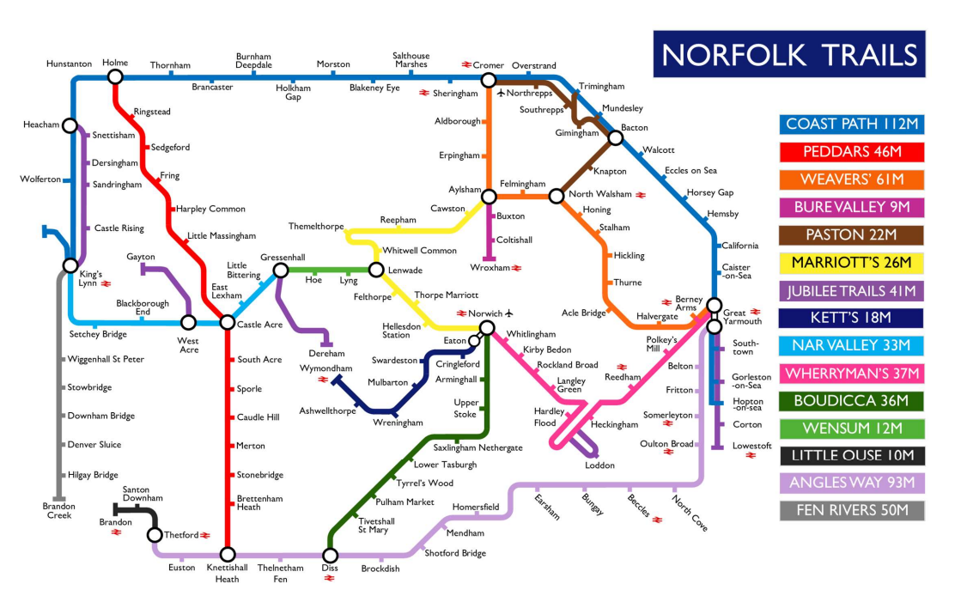

**Working Well Norfolk helping people with long-term health issues to keep working**

A scheme to support people in Norfolk with long-term health issues get back into employment or continue in their jobs has already helped more than 1,100 participants.

The Working Well Norfolk programme, launched in October 2023, supports individuals with long-term health issues to return to or stay in work. It has already helped over 1,100 participants, with 200 moving into work and 150 staying employed despite health challenges. The programme has received 1,600 referrals and will continue for another 18 months, with additional funding to help 730 more people, totalling 1,830 participants by September 2026. The £5.2m project is managed by Norfolk County Council and delivered by Seetec Pluss and Standguide Ltd. For more info or to refer, visit [**Working Well Norfolk - Seetec Pluss**](https://www.seetecpluss.co.uk/working-well-norfolk/) or call 01603 561054.

**Your County Councillor:**

The Necton and Launditch division covers around 80sq miles of mid Norfolk and stretches from Colkirk in the north to Necton in the south and from Beetley in the east to Rougham in the west. The division contains 24 parishes which have 18 parish councils and 3 parish meetings, whose meetings I endeavour to attend as regularly as possible.

The division will change at the next County Council election (possibly in 2026) due to a review of division boundaries across Norfolk carried out by the Boundary Commission. The change will see the parish of Necton replaced by the parishes of Swanton Morley and Hoe. The division will be renamed Launditch. The boundaries of any unitary council covering the Breckland area will require swift work to enable elections to the new authorities in 2027.

During the year I have attended meetings of the following committees as a voting member:

Council; Scrutiny Committee; Planning (Regulatory) Committee (Vice Chair); Audit and Governance Committee; Adult Social Care Performance Review Panel; Breckland Area Museums Committee; Norfolk Safeguarding Adults Board; Planning and Highways Delegations Committee (non voting).

Mark Kiddle-Morris, Member for Necton and Launditch.

May 2025.